Web Service “ProductExtract”

Description: Extraction of the product specific details, billing information and all product options, packages, coverages and health formulas.

Request Flow:

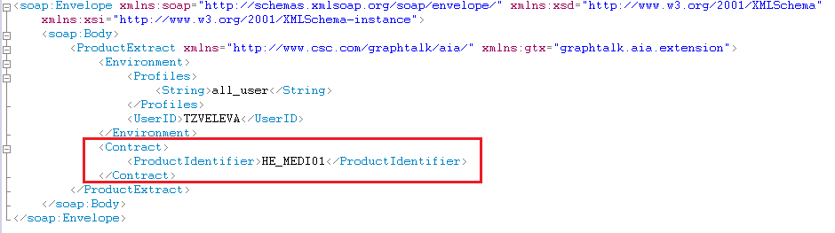

* ProductIdentifier: the unique identifier of the product;

Screens in GraphTalk A.I.A, corresponding with the extracted information:

1. Billing Screen

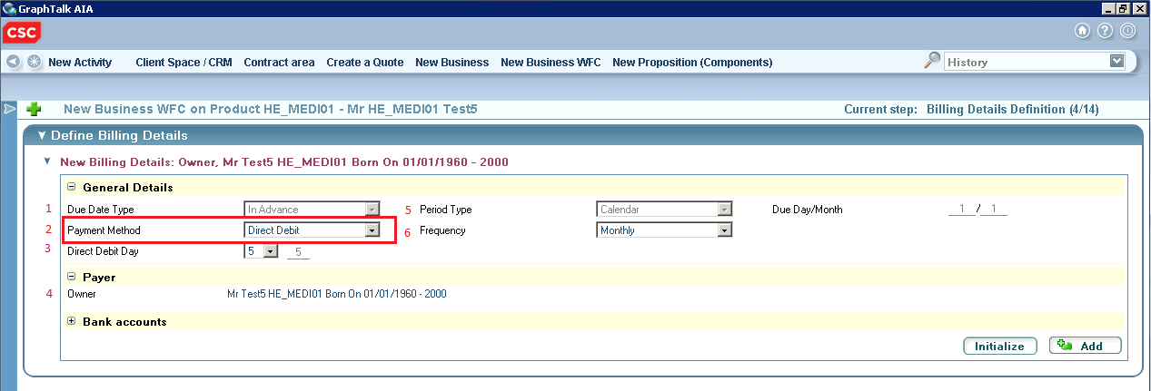

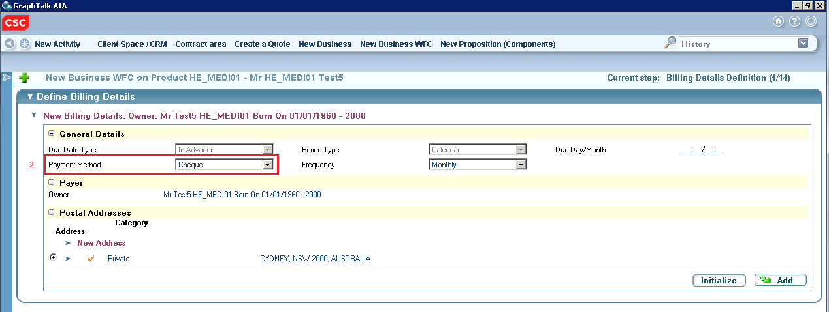

Response Flow Fragment for the Billing Information:

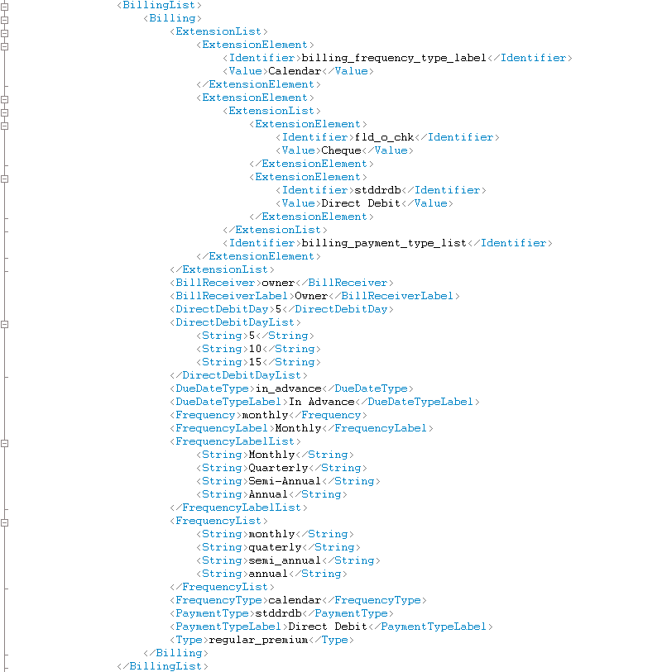

* ExtensionList with two ExtensionElement tags:

1. Value of the ExtensionElement with Identifier “billing_frequency_type_label”: label of the frequency type (5);
2. ExtensionLIst of the ExtensionElement with Identifier “billing_payment_type_list”: list of ExtensionElements with Identifiers and Values for available billing payment methods on the product (2).

* BillReceiver: the payer for that product is always the owner of the contract (4);
* BillReceiverLabel: label of the BillReceiver (4);
* DirectDebitDay: the day of the month for paying (3);
* DirectDebitDayList: possible direct debit days (3);

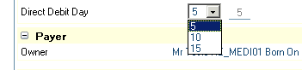

* DueDateType: one possible value “in_advance” (1);
* DueDateTypeLabel: label for the DueDateType (1);
* Frequency: the default frequency of the premium creation; for that product it is “monthly” (6);
* FrequencyLabel: label of the Frequency (6);
* FrequencyLabelList: list of labels of the available frequency periods for the product (6);

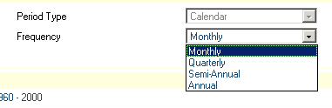

* FrequencyList: list of identifiers of the available frequency periods for the product (6);
* FrequencyType: frequency type (5);
* PaymentType: identifier of the default payment method (2);
* PaymentTypeLabel: label of the PaymentType (2);
* Type: type of the billing.

1. Options, Packages and Coverages screens:

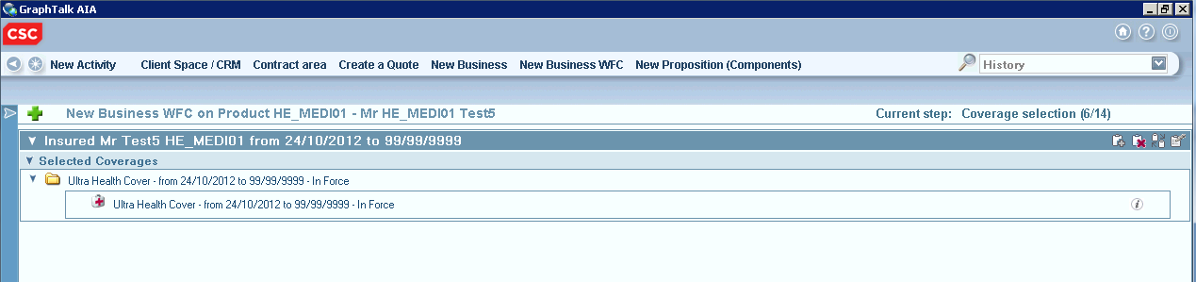

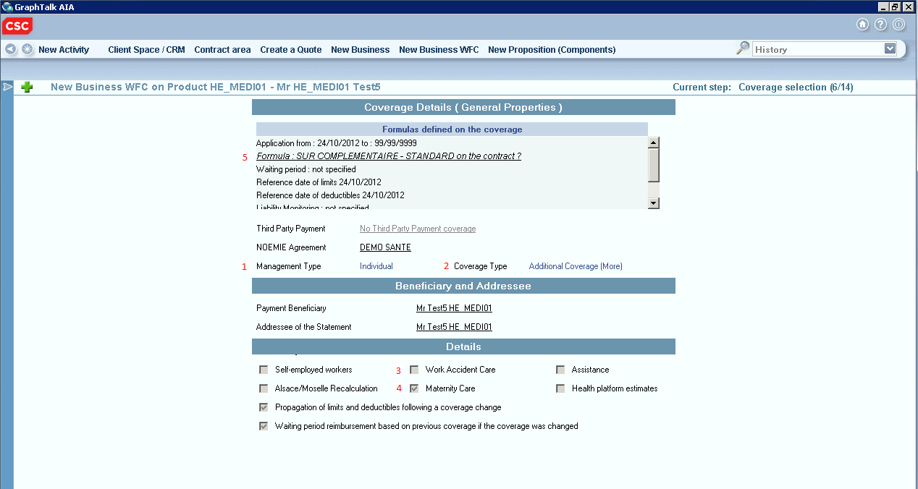

Response Flow Fragment for this health coverage:

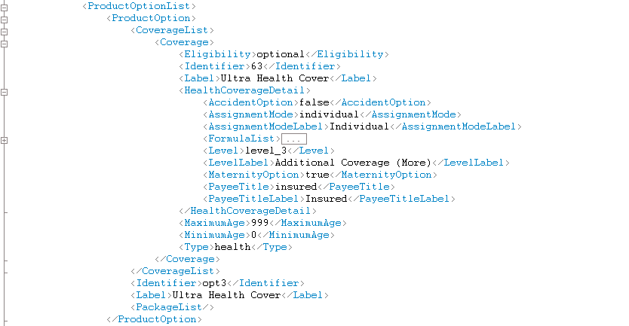

* HealthCoverageDetail:

1. AccidentOption (3);
2. AssignmentMode: management type (1);
3. AssignmentModeLabel: label of the AssignmentMode (1);
4. Level: coverage type (2);
5. LevelLabel: label of the Level (2);
6. MaternityOption (4);
7. PayeeTitle: type of the beneficiary;
8. PayeeTitleLabel: label of the PayeeTitle;
9. FormulaList: information and full details of the health formula for this coverage (5);

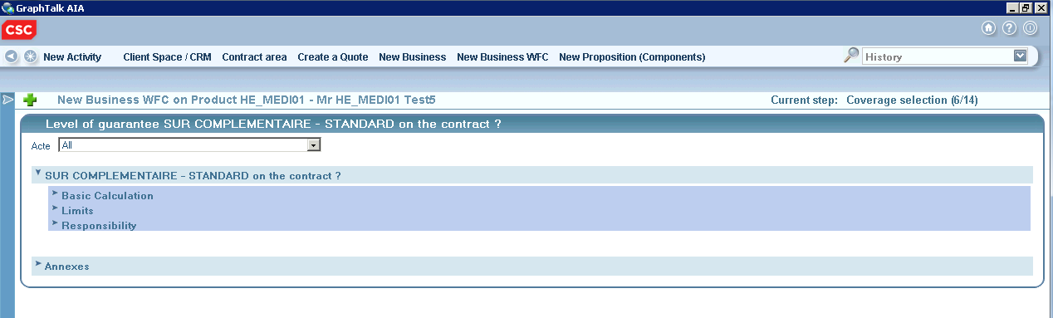

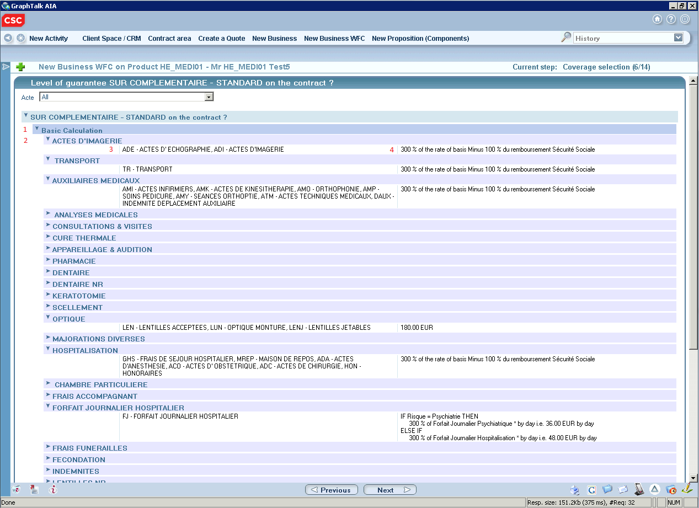

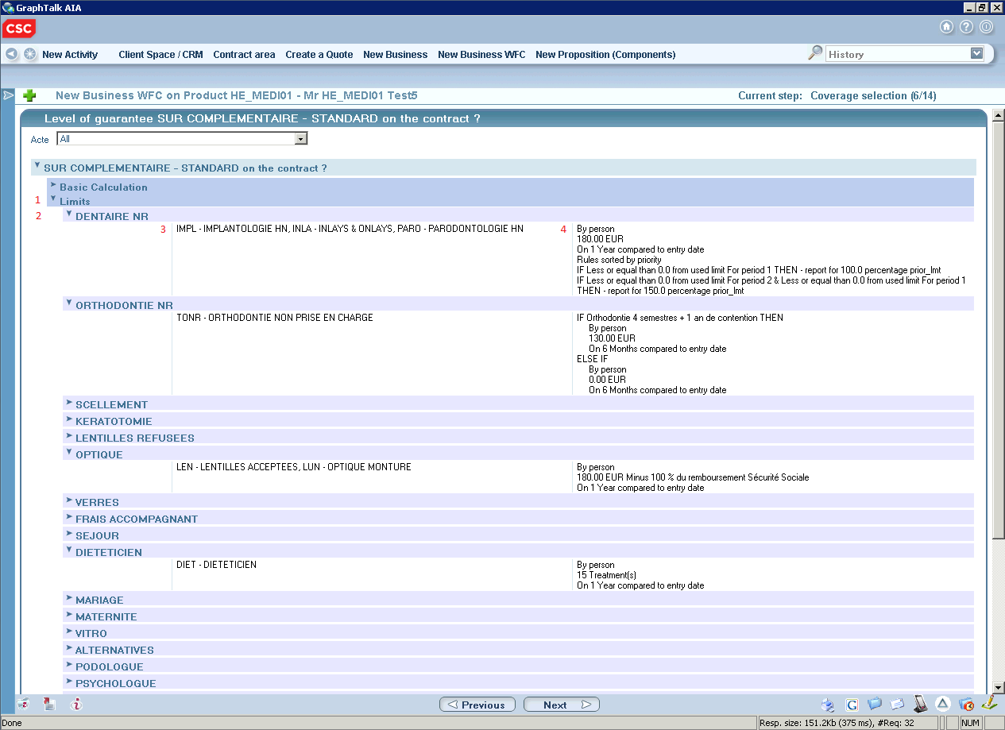

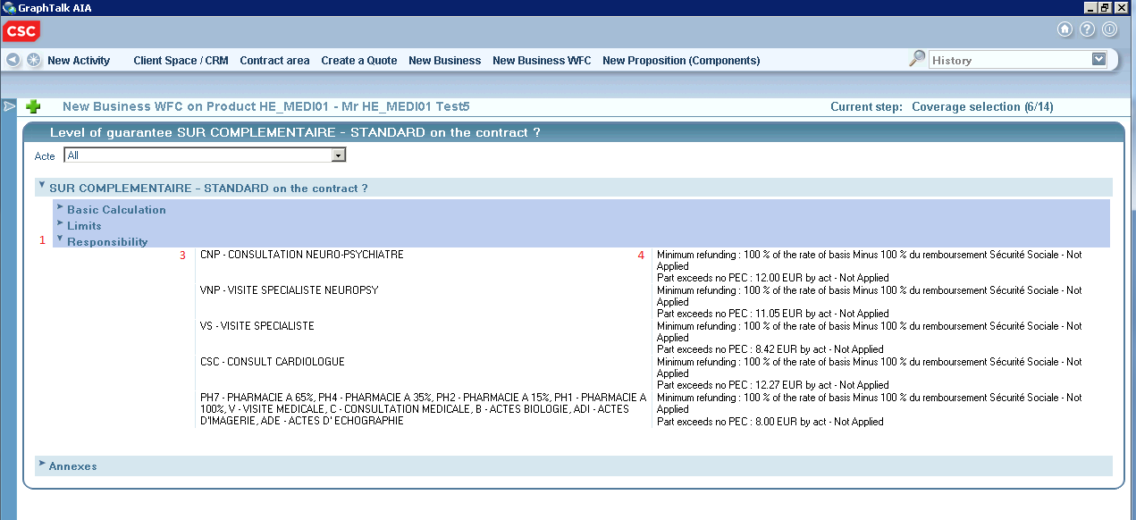

Response Flow Fragment for this health formula:

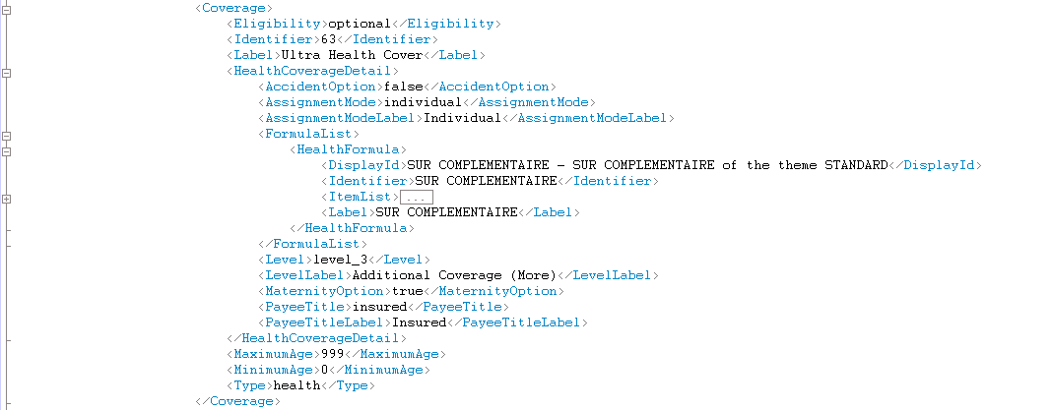

* Health Formula with label, identifier and full display;
* HealthFormula:ItemList: contains HealthFormulaItem tags with specific Type (1), TypeLabel (1) and TextList with details for the formula(health acts and health rules);

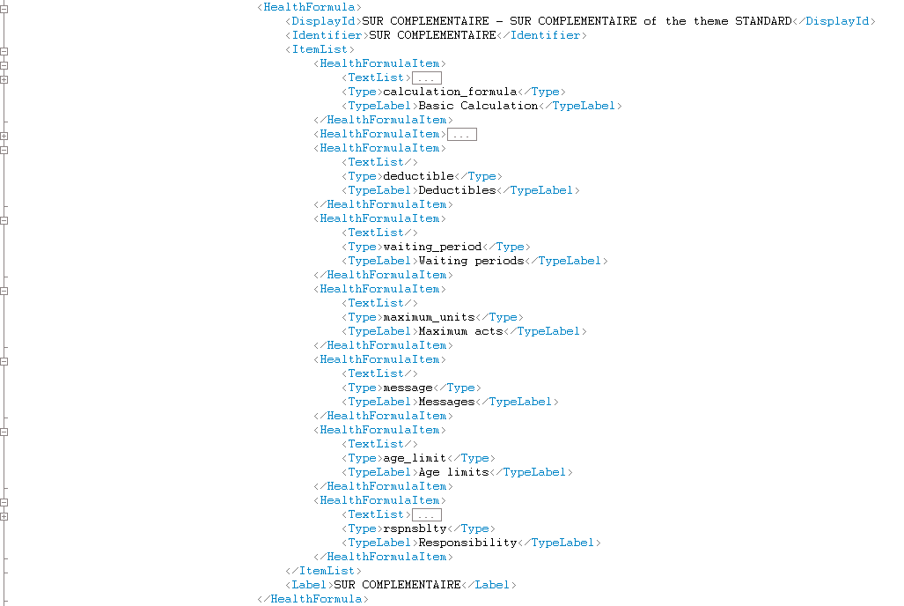

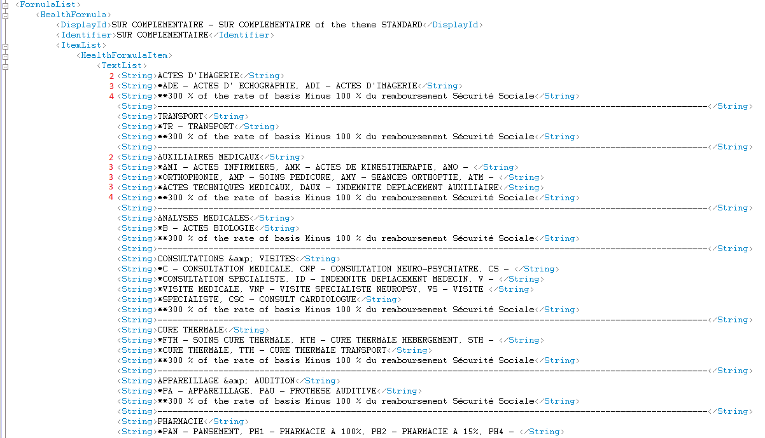

In the TextList:

* Line without “*” is the name of the group of the medical acts (2);
* Lines with one “*” contains the medical acts for the group from the previous line and their labels (3);
* Lines with two “*” contains the health rules (4);